**Data Structures and Algorithms**

**Project Documentation**

**TOUR NETWORK SYSTEM**

# Submitted by:

**Mirza Hasan Baig**

**FA21-BCS-040**

# Submitted to:

**Dr. Inayat Ur Rehman**

This project is a tour management system that operates through a console interface. It is designed to determine the most economical or fastest route between two locations, according to the customer's specifications.

**Data Structures** used in this system are:

* Linked List (Doubly),
* Graphs,
* Stack,
* Queue,
* Arrays

Three main modules of this project are:

1. **USER**
   1. Add User
   2. Display User
   3. Search User
   4. Update User
   5. Delete User
2. **ADMIN**
   1. Add/Update Company
   2. Employee Menu
   3. Assign Organizers
   4. Display Previous Trips
3. **TOUR CONFIRMATION**
   1. Add Package
   2. View Package
   3. Update Package
   4. Delete Package
   5. Calculate Cost
   6. Confirm Tour
   7. View Tour Organizer
4. **User:**  
   This project allows users to input their information in order to add themselves, as well as view, delete, and update their information.
5. **Admin:**

Admin menu allows only employees to access this menu. Employees are required to enter their username and password to access this menu.

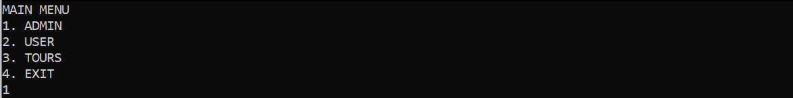

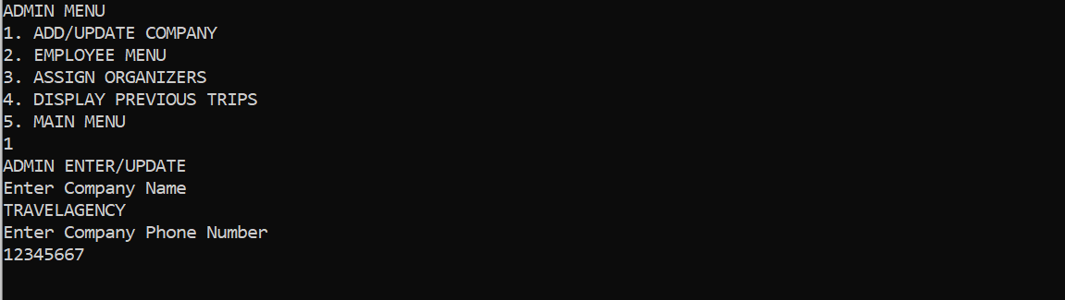

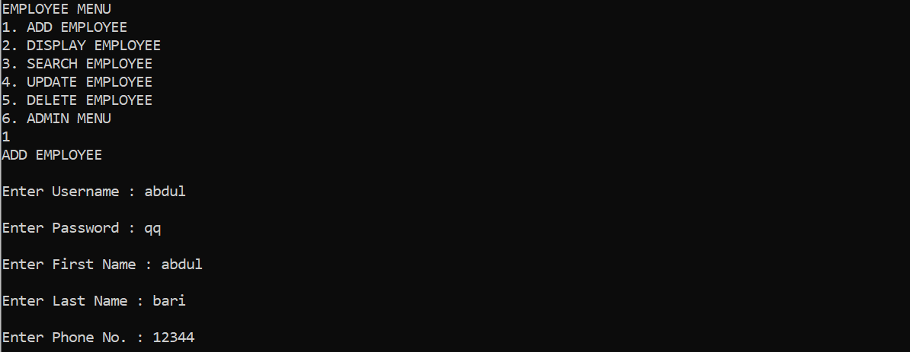

* 1. **Assign Organizer:**

The button assigns an organizer to each of the pending, confirmed packages of users that are in the queue, randomly selecting an employee for each package and then dequeuing it from the queue and pushing it into a stack for data storage.

* 1. **Display Previous Trip:**

This button displays every tour ever done by accessing package information in queue.

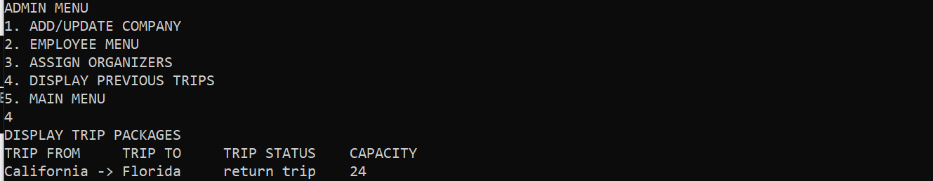

1. **Tour Confirmation:**

This menu allows a specific user to login so that he may add, update, view and delete package information.

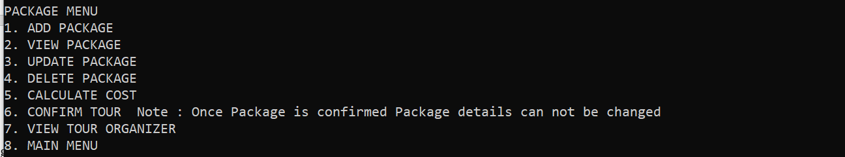

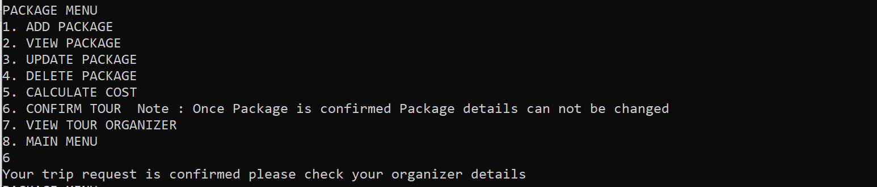

* 1. **Calculate Cost:**

User can view the least possible cost or time between two locations according to his package details and preferences i.e. cost effective tour or time effective tour.

1. **Cost Effective Trip:**





1. **Time Effective Trip:**



* 1. **Confirm Tour**

Once the user is sure of his package details he can access the confirm tour button which enqueue package details into a queue. And waits for the admin to assign organizer for tour.

* 1. **View Tour Organizer**

If the user is assigned with an organizer he can view his name and contact details in order to contact him.

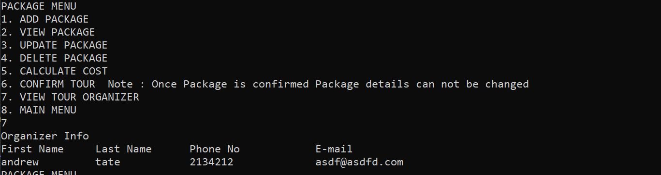

Graph with Respect to Cost:

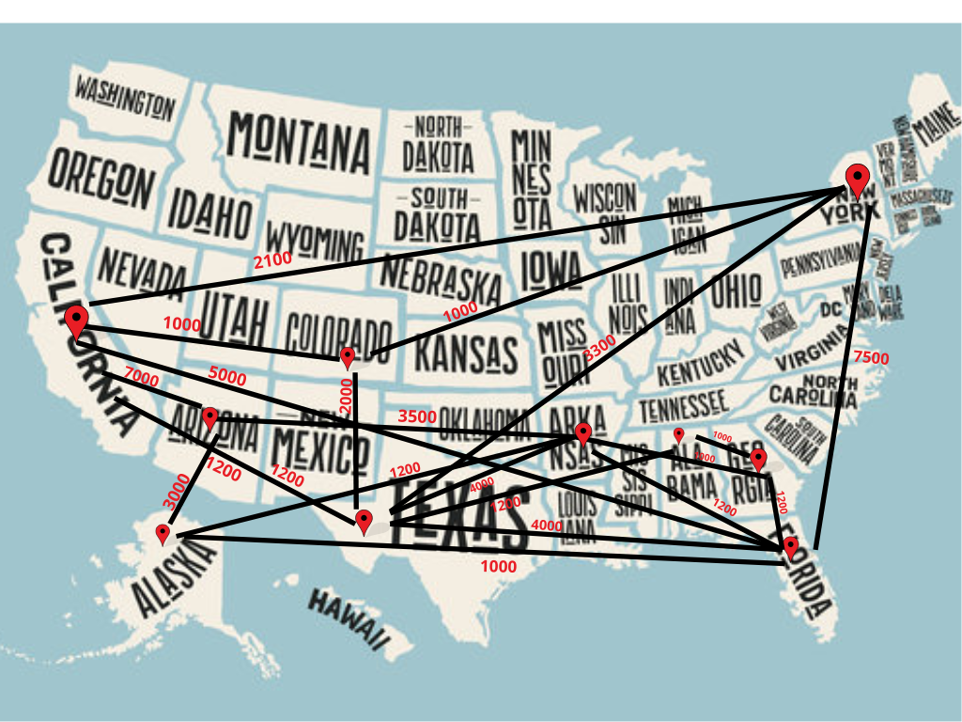

Graph with Respect to Time:

